5.Create Dockerfile, build an image, and run a custom container
Procedure
Step 1: Create a Project Directory
Open Terminal and run:
mkdir DockerDemo
Then:
cd DockerDemo
Step 2: Create an HTML File
Run:
index.html
Enter:
<!DOCTYPE html>
<html>
<head>
<title>Docker Lab</title>
</head>
<body>
<h1>Hello from My Docker Container!</h1>
<p>This webpage is running inside a Docker container.</p>
</body>
</html>
Save the file.
Step 3: Create a Dockerfile
Enter:
FROM nginx:latest
COPY index.html /usr/share/nginx/html/index.html
EXPOSE 80
Step 4: Build the Docker Image
Run:
docker build -t my-web-app .
1. Docker reads the Dockerfile.
2. Docker downloads the Nginx base image.
3. Docker copies the HTML file.
4. Docker creates the custom image.

Step 5: Verify the Docker Image
Run:
docker images
1. Find my-web-app in the list.
2. Verify that the image has been created.
Step 6: Run the Custom Container
Run:
docker run -d -p 8080:80 --name my-web-container my-web-app
1. Docker creates a container from the custom image.
2. Port 8080 on the host is connected to port 80 inside the container.
Step 7: Open the Web Application
1. Open a web browser.
2. Enter:
http://localhost:8080
3. Press Enter.
4. Verify that the custom webpage is displayed.
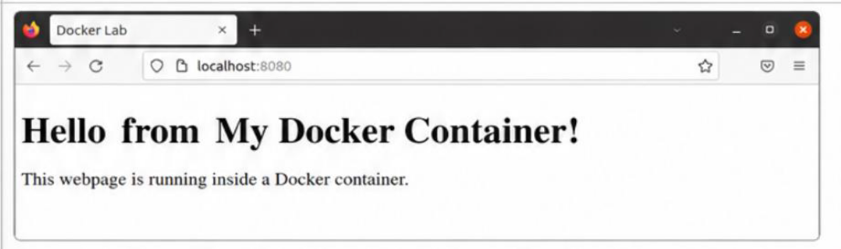

6.Use Docker Compose to run a web and database stack

Procedure
Step 1: Create a Project Directory
Run:
mkdir compose-lab
Then:
cd compose-lab
Step 2: Create the Compose File
Run:
compose.yaml
Enter:
services:
web:
image: nginx:latest
ports:
- "8080:80"
depends_on:
- db
db:
image: mysql:8.0
environment:
MYSQL_ROOT_PASSWORD: rootpassword
MYSQL_DATABASE: labdb
MYSQL_USER: labuser
MYSQL_PASSWORD: labpassword
Save the file.
Step 3: Start the Containers
Run:
docker compose up -d
1. Docker Compose reads the YAML file.
2. The Nginx web container is created.
3. The MySQL database container is created.
4. Both containers are started.
Step 4: Check Running Containers
Run:
sudo docker compose ps
1. Check the web service.
2. Check the db service.
3. Verify that both services are running.

Step 5: Access the Web Server
1. Open a web browser.
2. Enter:
http://localhost:8080
3. Press Enter.
4. Verify that the Nginx welcome page appears.
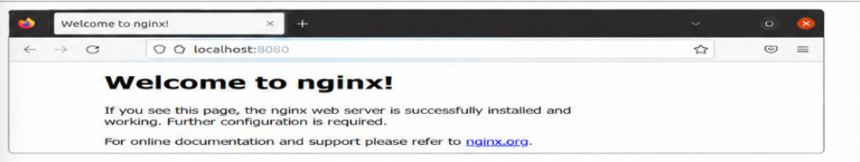
Step 6: Stop the Services
Run:
docker compose down
1. Docker Compose stops the running services.
2. The containers are removed.

